**Exp. No : 5**

# HIVE Installation

1. Download and Extract apache hive 3.1.2

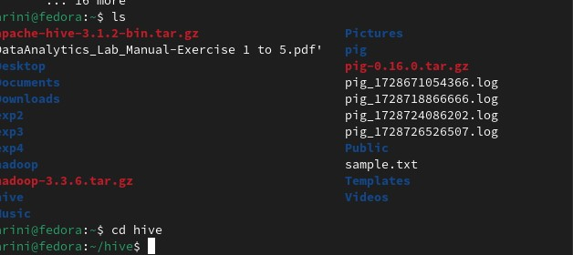

1. Update HIVE Configurations in .bashrc

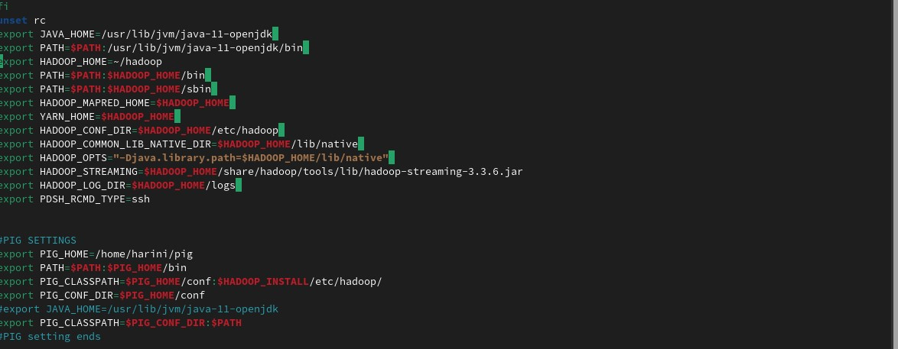

1. Change directory to apache-hive-3.1.2-bin/conf

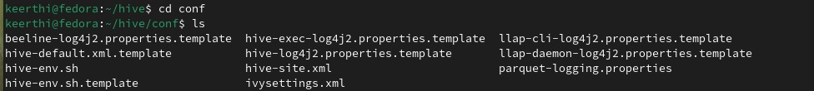

1. Create hive-env.sh

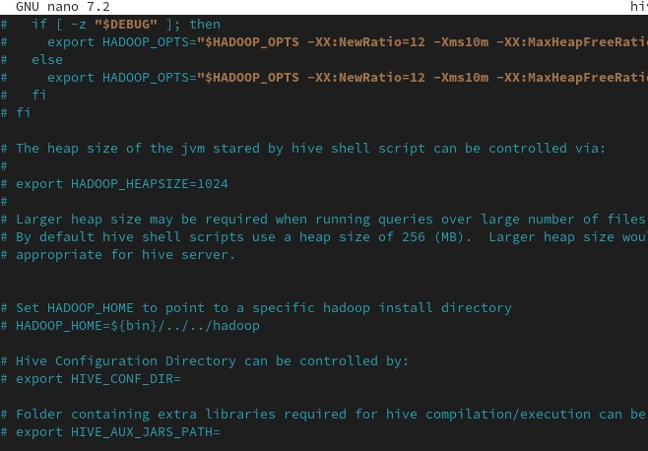

1. Install and Change mysql root password

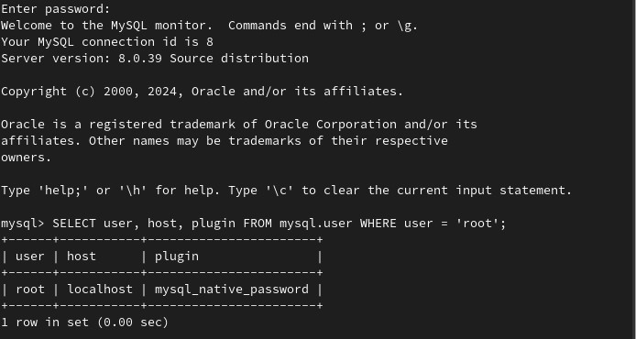

1. Create and configure hive-site.xml

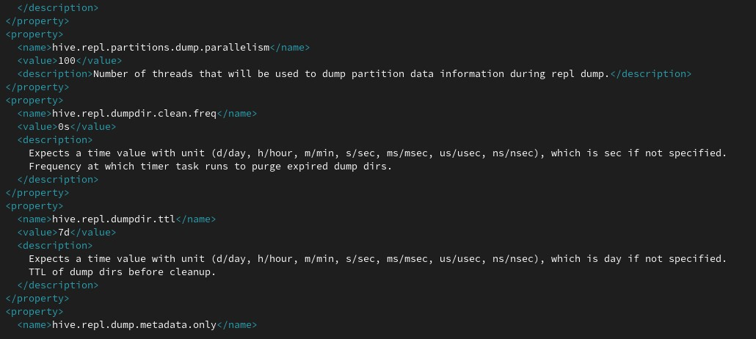

1. 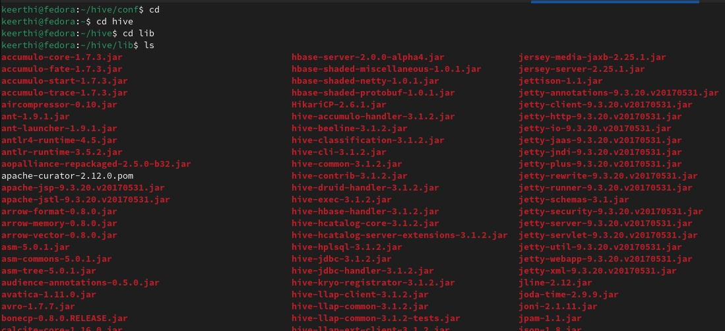Download and Move mysql java connector to apache-hive-3.1.2-bin/lib

1. Execute schematool -initSchema -dbType mysql

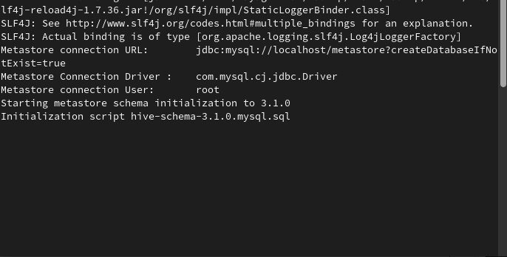

1. 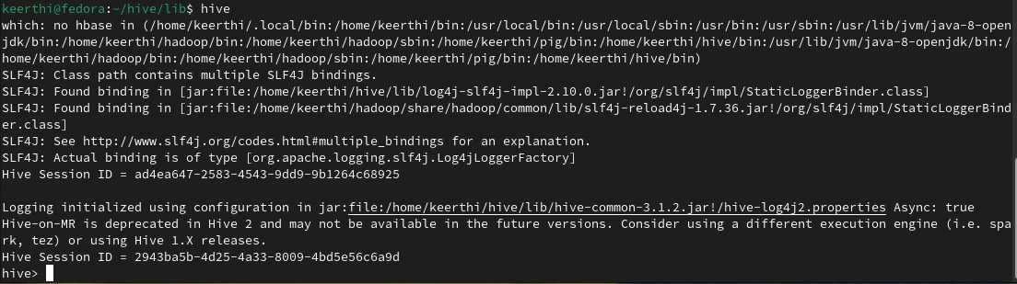Start hive